Press release
Contact
Sophie Kauffeld
Senior Managerin Corporate Communications & Public Affairs
Schunk Group
Rodheimer Straße 59
35452 Heuchelheim
Germany
Tel +49 641 608 2651
sophie.kauffeld@schunk-group.com
www.schunk-group.com

Windhoffest at the Heuchelheim site

Schunk donates €10,000 to Hessischer Jugendring
Heuchelheim, October 17, 2026 – Nearly 800 retirees, jubilarians and guests gathered at the Schunk Group’s traditional Windhoffest in the company restaurant in Heuchelheim.
The event provided an opportunity for CEO Peter R. Manolopoulos to give attendees an update on the company’s current development. He explained that fiscal year 2025 had been shaped by a challenging economic environment. Geopolitical conflicts, trade disputes and the continued weakness of key customer markets also affected the Schunk Group.
At the same time, he emphasized the company’s strong position. In fiscal year 2025, the Schunk Group generated revenue of around €1.7 billion, remained profitable and continued to maintain an equity ratio of almost 70 percent. In addition, the company invested approximately €125 million in its future over the past year.
Looking ahead, Manolopoulos outlined the Schunk Strategy 2030, which is designed to create the foundation for profitable growth in the years to come. The ongoing “Focus on Performance” program, aimed at increasing productivity and profitability, is already delivering results. The positive development in order intake is seen by the company as confirmation that it is on the right path.
Strengthening young people’s participation in society
As part of the Windhoffest tradition, the Schunk Group supports a non-profit organization each year. This year, the Windhoffest donation of €10,000 was awarded to the Hessischer Jugendring (Hessian Youth Council).
The Hessischer Jugendring is the umbrella organization of youth associations in the German state of Hesse and the largest representative body for children and young people in the region. Together with its member organizations, it promotes volunteer engagement, non-formal youth education, and the participation of young people in social and democratic processes.
“Democracy education for young people is more important today than ever before. It is equally important to strengthen volunteer engagement and encourage people to remain actively involved despite an increasingly challenging social climate. Thanks to the support of the Schunk Group, we will be able to offer additional democracy education project days for young people and further expand our programs for volunteers in youth associations across Hesse,” said Reiner Jäkel, Managing Director of the Hessischer Jugendring.
A long-standing gathering for retirees and jubilarians
For many former Schunk employees, the Windhoffest is a welcome opportunity each year to return to their former workplace and reconnect with former colleagues. As in previous years, the Kinzenbach Brass Band and the team of the Schunk company restaurant helped create a welcoming atmosphere for the event.

(2.809 characters including spaces)

Image material (2 photos)
Publication free of charge. Please credit the source as “Schunk Group”.
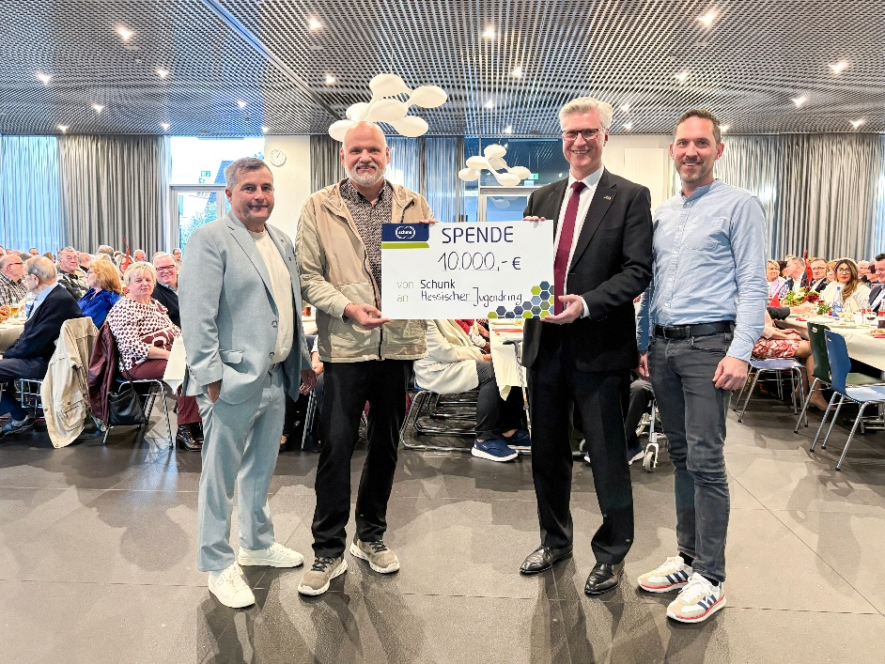
Photo 1: Steffen Friedrich, Head of Human Resources Germany (left), and Schunk Group CEO Peter R. Manolopoulos (second from right) present the Windhoffest donation of €10,000 to Reiner Jäkel, Managing Director of the Hessischer Jugendring (second from left), and Deputy Managing Director Klaus Bechtold.
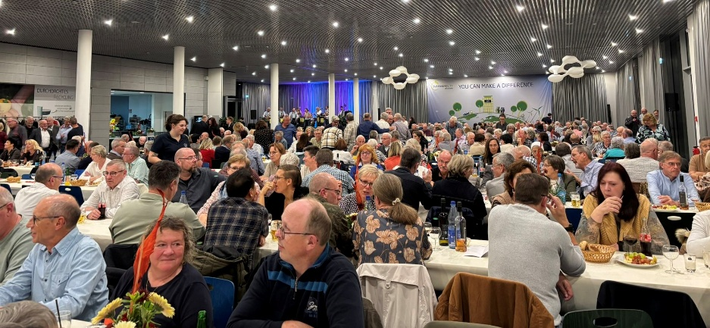

Photo 2: The traditional Windhoffest has enjoyed strong attendance for many years. Once again, hardly a seat remained available in the company restaurant in Heuchelheim.

About the Schunk Group
The Schunk Group is a global technology group. The company is a leading supplier of products made from high tech materials – such as carbon, technical ceramics, and sintered metal – as well as machines and systems – from environmental simulation, climate control, and ultrasonic welding to optical machines. The company was founded in 1913 and today has more than 10,000 employees at 64 locations in 26 countries worldwide. In 2025, the Schunk Group generated sales of around €1.7 billion.

