Press Release
Contact
Dr. Carola Hilbrand
Corporate Communications , and Public Affairs
Schunk Group
Rodheimer Straße 59
35452 Heuchelheim
Germany
Tel +49 641 608 2285
carola.hilbrand@schunk-group.com
www.schunk-group.com

Schunk Group Supports Martin Buber School: €10,000 Donation for More Participation
Heuchelheim/Giessen, March 20, 2026 – A new van brings more freedom to the daily lives of students at the Martin Buber School in Giessen. The purchase of the van was supported by a donation from the Schunk Group.
Great joy in the schoolyard of the Martin Buber School in Giessen: Under bright sunshine, numerous students cheered for their new van—a vehicle that will make field trips, class trips, and group activities possible in the future. The purchase and the installation of a ramp were supported by a 10,000-euro donation from the Schunk Group. The idea for the donation came from within the company’s own ranks, from employee Inka Schwarz, whose daughter Emma attends school here.
The donation is the result of several initiatives: As part of the global employee initiative “Schunk Runs,” employees covered nearly 100,000 kilometers for a good cause last year, raising nearly 5,000 euros. The company had pledged to donate 5 cents per kilometer. In addition, the works council’s Christmas fundraising campaign at the Heuchelheim site raised around 3,800 euros from employees. The Schunk Group’s management ultimately rounded the amount up to 10,000 euros.
For the school, the van is a huge help. Many of the children and young people rely on assistive devices that are difficult to transport. For others, the sensory overload on public transportation is a nearly insurmountable burden.
Mobility means participation
“The Schunk Group’s donation gives us freedom,” said Principal Dr. Gabriele Kremer at the handover. The bus opens up entirely new possibilities for the students—such as trips to the forest, to the strawberry fields, or group field trips. “Such experiences are incredibly important for our children. They enable participation and genuine community.”
The Martin Buber School is a special education school focusing on intellectual development as well as physical and motor development. In small classes and with individually tailored support plans, children and adolescents are supported in their development. The school’s goal is to prepare students for as independent a life as possible. About 170 children and adolescents are taught at the Giessen campus, and about 50 in the vocational orientation program in Biebertal.
A school with a whole lot of passion
In addition to classroom instruction, creative and athletic activities play an important role in everyday school life—something that can often be a challenge during free time, as such opportunities are few and far between or involve expenses that families cannot cover on their own. For example, there is a choir and a band, dance classes and cheerleading, as well as swimming lessons in the school’s own pool.
The visit left a lasting impression on the Schunk Group representatives. Steffen Friedrich, Head of Human Resources for Germany at the Schunk Group: “We were deeply moved by the dedication and passion with which people work here. We are all the more pleased to be able to contribute to this as a company.” Simon Alsmeier, Chairman of the Schunk Group’s Group Works Council, and Dirk Waldschmidt, who advocates for “Schunk läuft” on behalf of the Works Council, added: “When you walk through the facilities, it becomes clear: the donation is going to the right organization.”
The students have already enthusiastically taken over the new bus: Amid loud cheers, they’re testing out the spacious cargo area—and are already looking forward to their first trip together.
(3,389 characters including spaces)

Images:
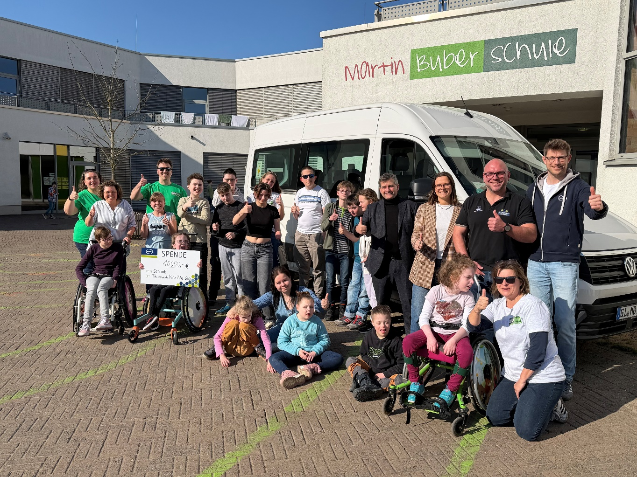
Image 1: Great joy over the donation from the Schunk Group and its employees: Students at the Martin Buber School in Giessen are thrilled with the new van, which was purchased with the support of the donation. The vehicle enables field trips and class trips for greater participation.
Reproduction free of charge. Please cite the Schunk Group as the source.

About the Schunk Group
The Schunk Group is a global technology group. The company is a leading supplier of products made from high-tech materials—such as carbon, technical ceramics, and sintered metal—as well as machines and systems—ranging from environmental simulation and climate control technology to ultrasonic welding and optical machines. The Schunk Group employs approximately 10,000 people in 26 countries and generated revenue of approximately 1.7 billion euros in 2025.

