Press release
Contact
Dr. Carola Hilbrand
Corporate Communications , and Public Affairs
Schunk Group
Rodheimer Straße 59
35452 Heuchelheim
Germany
Tel
carola.hilbrand@schunk-group.com
www.schunk-group.com

Balance of interests agreed at Weiss Technik
Heuchelheim, February 27, 2026 – The crisis in the automotive industry is also affecting Weiss Technik GmbH. The management and works council committees at the Reiskirchen and Balingen sites have now agreed on the second part of a reconciliation of interests.
The automotive industry remains in crisis – corporations and their suppliers are postponing or canceling investments. This also affects Weiss Technik GmbH, a subsidiary of the Schunk Group. Due to a massive slump in orders from the automotive industry, the company and employee representatives negotiated the first part of a reconciliation of interests in mid-2025. This provided for a reduction in capacity and the need for structural measures at the Reiskirchen and Balingen sites. A social plan was agreed and a voluntary program was launched, through which employees could also transfer to a transfer company.
The second part of the reconciliation of interests has now been agreed, and employees were informed of this today. In addition to the measures developed, such as outsourcing, digitalization, and process optimization to reduce manufacturing costs, this also provides for training measures and job security until December 31, 2028.
Due to a slight stabilization in order intake, around 20 percent fewer jobs will have to be cut than assumed at the start of negotiations, with only 285 instead of 357. The majority of these employees have already left the company. At the start of 2025, Weiss Technik employed around 1,350 people in Reiskirchen and Balingen.
"There is no sign of a significant improvement in the automotive crisis. We must adapt to permanently changed market conditions," said Weiss Technik managing directors Dr. Daniel Allendorf and Peter Kuisle: "We are pleased that we have found good solutions that both offer prospects for the employees affected and relieve the burden on our company."
"The employees were able to contribute to the development of the structural measures. After all, they know their areas best," said Johanna Köhler and Rainer Willmer, the works council chairpersons at the two locations: "Some of the measures developed by the employees were incorporated into the reconciliation of interests."
(2,129 characters including spaces)

Image material:
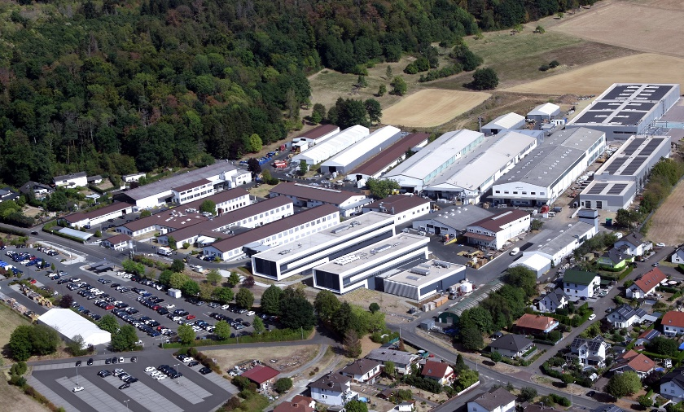
Image 1: At Weiss Technik GmbH (pictured: Reiskirchen site), the company management and the works council committees of the Reiskirchen and Balingen sites have agreed on the second part of the reconciliation of interests.
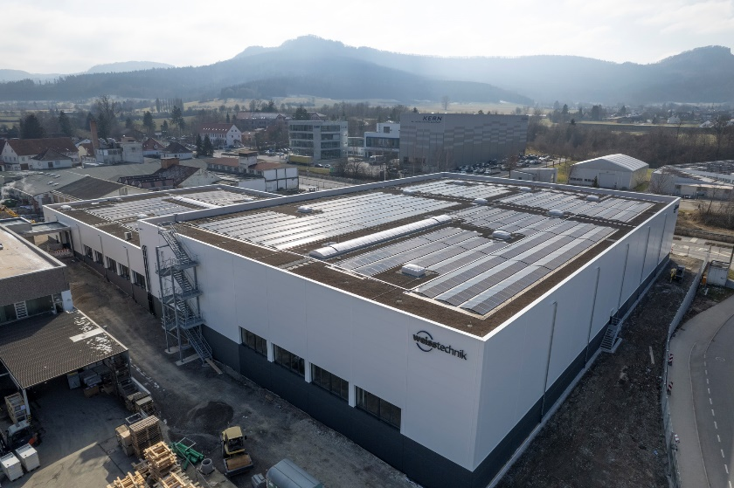
Image 2: Balingen site of Weiss Technik GmbH.
Reproduction free of charge. Please cite Schunk Group as the source.

About the Schunk Group
The Schunk Group is a global technology group. The company is a leading supplier of products made from high-tech materials – such as carbon, technical ceramics, and sintered metal – as well as machines and systems – from environmental simulation, climate control, and ultrasonic welding to optical machines. The Schunk Group has around 10,000 employees in 26 countries and generated sales of around 1.7 billion euros in 2025.

